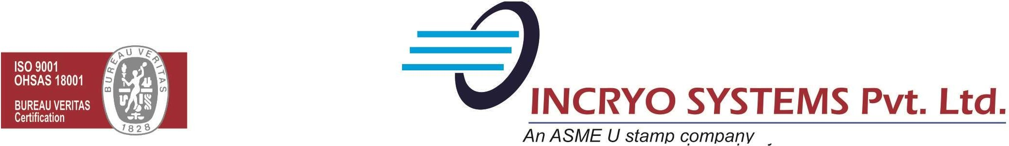

INCRYO MANUFACTURING PRODUCT RANGE

Our Product Range

- Cryogenic Storage tank ( Standard Storage / Thermo Siphon ) for LOX/LIN/LAR/LCO2/LNG – HSN : 73110090
- Ambient Natural draft vaporizers – HSN : 84195010
- Ambient Forced draft vaporizers – HSN : 84195010
- Ambient Pressure building vaporizers – HSN : 84195010
- Ambient LNG vaporizers – HSN : 84195010
- Dual gas purging vaporizers – HSN : 84195010
- Electric fluid bath and plate vaporizers – HSN : 84195010
- Steam Heated vaporizers– HSN : 84195010
- Water heated vaporizers– HSN : 84195010
- Fuel fired water heated vaporizers– HSN : 84195010
- Pressure vessels and tanks – HSN : 7311
- Flare and disposal vaporizers HSN : 84195010
- CO2 vaporizers and Process equipment HSN : 84195010
- Cryogenic pumps and valves – HSN : 84818030
- High Pressure cylinder filling manifolds - HSN : 73071110
- Process gas supply skids - HSN : 8537
- Re-gasification skids - HSN : 8537
- Vacuum Insulated Piping - - HSN : 8414
- Reciprocating Pump for Cylinder Filling application.
- Manifold Systems for Cylinder Filling.- HSN : 73071110
